Warm Up Activity

Excerpt from The Zimmerman Telegram by Barbara Tuchman.

The first message of the morning watch plopped out of the pneumatic tube into a wire basket with no more premonitory rattle than usual. The duty officer at the British Naval Intelligence twisted open the cartridge and examined the German wireless intercept it contained without noting anything of unusual significance. When a glance showed him that the message was in non-naval code, he sent it in to the Political Section in the inner room and thought no more about it. The date was January 17, 1917, past the halfway mark of a war that had already ground through thirty months of reckless carnage and no gain. (p. 3)

Source – Tuchman, B. W. (1979). The Zimmerman Telegram. Ballantine Books: New York.

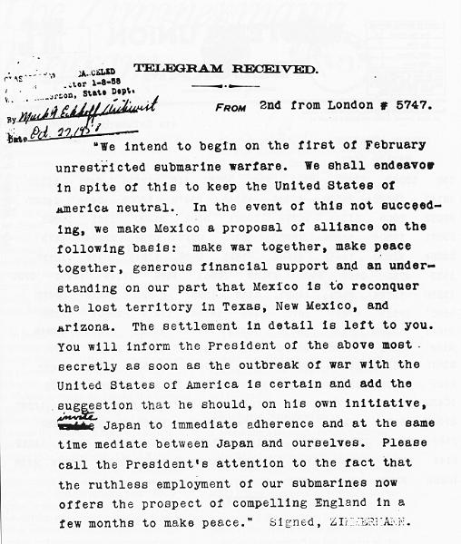
Source: Electronic copy of telegram from U.S. National Archives and Records Administration, Washington, D.C.

