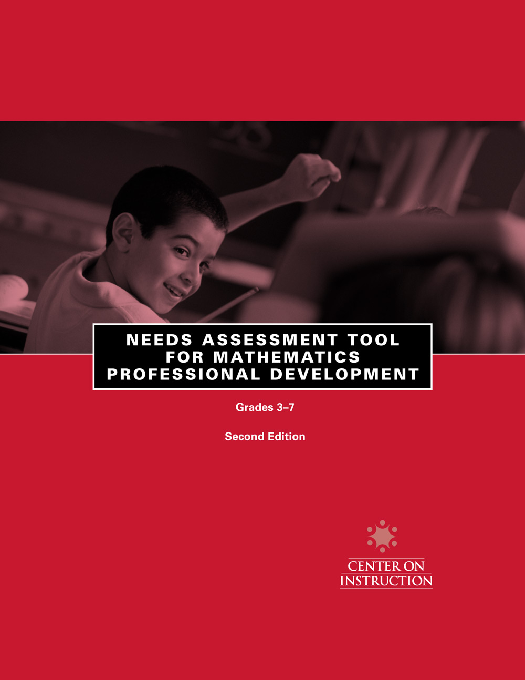


Needs assessment tool for mathematics professional development, Second edition

Grade 3

A. Benchmarks for the critical foundations  [color code based on column D] | B. Related state content standards | C. Related test  items and percent  of students with  correct answers for  each relevant | D. Average  percent  meeting  benchmark
 |  | e.g. Item 1, 80%  e.g. Item 11, 40%  e.g. Item 70, 60% | e.g. 60%
Fluency with whole numbers: By the end of Grade 5 or 6, children should have a robust sense of number. This sense of number must include an understanding of place value and the ability to compose and decompose whole numbers. It must clearly include a grasp of the meaning of the basic operations of addition, subtraction, multiplication, and division. It must also include use of the commutative, associative, and distributive properties; computational facility; and the knowledge of how to apply the operations to problem solving. Computational facility requires the automatic recall of addition and related subtraction facts, and of multiplication and related division facts. It also requires fluency with the standard algorithms for addition, subtraction, multiplication, and division. Fluent use of the algorithms not only depends on the automatic recall of number facts but also reinforces it. A strong sense of number also includes the ability to estimate the results of computations and thereby to estimate orders of magnitude, e.g., how many people fit into a stadium or how many gallons of water are needed to fill a pool.
1. By the end of grade 3, students should be proficient with the addition and subtraction of whole numbers. This includes developing a robust sense of place value, composing and decomposing whole numbers, and use of the commutative and associative properties. Computational facility and estimation is expected.
2. By the end of grade 5, students should be proficient with multiplication and division of whole numbers. This includes the understanding and use of the distributive property, developing a robust sense of place value, computational facility and how the operations are interconnected.

(continued)

Needs assessment tool for mathematics professional development, Second edition

Grade 3

A. Benchmarks for the critical foundations  [color code based on column D] | B. Related state content standards | C. Related test  items and percent  of students with  correct answers for  each relevant | D. Average  percent  meeting  benchmark
 |  | e.g. Item 1, 80%  e.g. Item 11, 40%  e.g. Item 70, 60% | e.g. 60%
Fluency with fractions: Before they begin algebra course work, students should have a thorough understanding of positive as well as negative fractions. Understanding of fraction concepts begins in primary and intermediate grades. Middle school students should be able to locate positive and negative fractions on a number line; represent and compare fractions, decimals, and related percent; and estimate their size. They need to know that sums, differences, products, and quotients (with nonzero denominators) of fractions are fractions, and they need to be able to carry out these operations confidently and efficiently. They should understand why and how (finite) decimal numbers are fractions and know the meaning of percent.
1. By the end of grade 4, students should be able to identify and represent fractions and decimals, and compare them on a number line or with other common representations of fractions and decimals. This includes understanding how changing the unit makes the fractional value of a given amount different.
2. By the end of Grade 5, students should be proficient with comparing fractions and decimals and common percents, and with the addition and subtraction of fractions and decimals.

(continued)

Needs assessment tool for mathematics professional development, Second edition

Grade 3

A. Benchmarks for the critical foundations  [color code based on column D] | B. Related state content standards | C. Related test  items and percent  of students with  correct answers for  each relevant | D. Average  percent  meeting  benchmark
 |  | e.g. Item 1, 80%  e.g. Item 11, 40%  e.g. Item 70, 60% | e.g. 60%
Geometry and measurement: Middle grade students should be able to analyze the properties of two-and three-dimensional shapes using formulas to determine perimeter, area, volume, and surface area. They should also be able to find unknown lengths, angles, and areas. Understanding of geometry and measurement concepts begins in primary and intermediate grades.
1. By the end of grade 5 students should be able to solve problems involving perimeter and area of triangles and all quadrilaterals having at least one pair of parallel sides (i.e., trapezoids). This includes understanding multiplication and its conceptual connections to area.

(continued)

Needs assessment tool for mathematics professional development, Second edition

Grade 4

A. Benchmarks for the critical foundations  [color code based on column D] | B. Related state content standards | C. Related test  items and percent  of students with  correct answers for  each relevant | D. Average  percent  meeting  benchmark
 |  | e.g. Item 1, 80%  e.g. Item 11, 40%  e.g. Item 70, 60% | e.g. 60%
Fluency with whole numbers: By the end of Grade 5 or 6, children should have a robust sense of number. This sense of number must include an understanding of place value and the ability to compose and decompose whole numbers. It must clearly include a grasp of the meaning of the basic operations of addition, subtraction, multiplication, and division. It must also include use of the commutative, associative, and distributive properties; computational facility; and the knowledge of how to apply the operations to problem solving. Computational facility requires the automatic recall of addition and related subtraction facts, and of multiplication and related division facts. It also requires fluency with the standard algorithms for addition, subtraction, multiplication, and division. Fluent use of the algorithms not only depends on the automatic recall of number facts but also reinforces it. A strong sense of number also includes the ability to estimate the results of computations and thereby to estimate orders of magnitude, e.g., how many people fit into a stadium or how many gallons of water are needed to fill a pool.
1. By the end of grade 5, students should be proficient with multiplication and division of whole numbers. This includes the understanding and use of the distributive property, and developing a robust sense of place value, computational facility, and how the operations are interconnected.

(continued)

Needs assessment tool for mathematics professional development, Second edition

Grade 4

A. Benchmarks for the critical foundations  [color code based on column D] | B. Related state content standards | C. Related test  items and percent  of students with  correct answers for  each relevant | D. Average  percent  meeting  benchmark
 |  | e.g. Item 1, 80%  e.g. Item 11, 40%  e.g. Item 70, 60% | e.g. 60%
Fluency with fractions: Before they begin algebra course work, middle school students should know that sums, differences, products, and quotients (with nonzero denominators) of fractions are fractions, and they need to be able to carry out these operations confidently and efficiently. They should understand why and how (finite) decimal numbers are fractions and know the meaning of percent. Beyond computational facility with specific numbers, the subject of fractions, when properly taught, introduces students to the use of symbolic notation and the concept of generality, both being integral parts of algebra.
1. By the end of grade 4, students should be able to identify and represent fractions and decimals, and compare them on a number line or with other common representations of fractions and decimals. This includes understanding how division and fractions are related and the part/whole nature of fractions.
2. By the end of Grade 5, students should be proficient with comparing fractions and decimals and common percent, and with the addition and subtraction of fractions and decimals. This includes the part/whole nature of fractions verses the part/part or part/whole nature of ratios.
3. By the end of grade 6, students should be proficient with multiplication and division of fractions and decimals. This includes understanding generalizations such as the multiplication of rational numbers less than one but greater than 0 produces a smaller product.
4. By the end of grade 6, students should be proficient with all operations involving positive and negative integers.

(continued)

Needs assessment tool for mathematics professional development, Second edition

Grade 4

A. Benchmarks for the critical foundations  [color code based on column D] | B. Related state content standards | C. Related test  items and percent  of students with  correct answers for  each relevant | D. Average  percent  meeting  benchmark
 |  | e.g. Item 1, 80%  e.g. Item 11, 40%  e.g. Item 70, 60% | e.g. 60%
Geometry and measurement: Middle grade students should be able to analyze the properties of two-and three-dimensional shapes using formulas to determine perimeter, area, volume, and surface area. They should also be able to find unknown lengths, angles, and areas. Understanding of geometry and measurement concepts begins in primary intermediate grades.
1. By the end of grade 5, students should be able to solve problems involving perimeter and area of triangles and all quadrilaterals having at least one pair of parallel sides (i.e., trapezoids, rhombus). This includes visualizing how a composite shape decomposes into others shapes.
2. By the end of grade 6, students should be able to analyze the properties of two dimensional shapes and solve problems involving perimeter and area, and analyze the properties of three-dimensional shapes and solve problems involving surface area and volume.

(continued)

Needs assessment tool for mathematics professional development, Second edition

Grade 5

A. Benchmarks for the critical foundations  [color code based on column D] | B. Related state content standards | C. Related test  items and percent  of students with  correct answers for  each relevant | D. Average  percent  meeting  benchmark
 |  | e.g. Item 1, 80%  e.g. Item 11, 40%  e.g. Item 70, 60% | e.g. 60%
Fluency with whole numbers: By the end of Grade 5 or 6, children should have a robust sense of number. This sense of number must include an understanding of place value and the ability to compose and decompose whole numbers. It must clearly include a grasp of the meaning of the basic operations of addition, subtraction, multiplication, and division. It must also include use of the commutative, associative, and distributive properties; computational facility; and the knowledge of how to apply the operations to problem solving. Computational facility requires the automatic recall of addition and related subtraction facts, and of multiplication and related division facts. It also requires fluency with the standard algorithms for addition, subtraction, multiplication, and division. Fluent use of the algorithms not only depends on the automatic recall of number facts but also reinforces it. A strong sense of number also includes the ability to estimate the results of computations and thereby to estimate orders of magnitude, e.g., how many people fit into a stadium or how many gallons of water are needed to fill a pool.
1. By the end of grade 5, students should be proficient with multiplication and division of whole numbers. This includes the understanding and use of the distributive property, and developing a robust sense of decimal place value, computational facility, and how the operations are interconnected.

(continued)

Needs assessment tool for mathematics professional development, Second edition

Grade 5

A. Benchmarks for the critical foundations  [color code based on column D] | B. Related state content standards | C. Related test  items and percent  of students with  correct answers for  each relevant | D. Average  percent  meeting  benchmark
 |  | e.g. Item 1, 80%  e.g. Item 11, 40%  e.g. Item 70, 60% | e.g. 60%
Fluency with fractions: Before they begin algebra course work, middle school students should have a thorough understanding of positive as well as negative fractions. They should be able to locate positive and negative fractions on a number line; represent and compare fractions, decimals, and related percent; and estimate their size. They need to know that sums, differences, products, and quotients (with nonzero denominators) of fractions are fractions, and they need to be able to carry out these operations confidently and efficiently. They should understand why and how (finite) decimal numbers are fractions and know the meaning of percent. They should encounter fractions in problems in the many contexts in which they arise naturally, for example, to describe rates, proportionality, and probability. Beyond computational facility with specific numbers, the subject of fractions, when properly taught, introduces students to the use of symbolic notation and the concept of generality, both being integral parts of algebra.
1. By the end of Grade 5, students should be proficient with comparing common fractions and decimals and common percent, and with the addition and subtraction of fractions and decimals. This includes the part/whole nature of fractions verses the part/part or part/whole nature of ratios.
2. By the end of grade 6, students should be proficient with multiplication and division of fractions and decimals. This includes understanding generalizations such as the multiplication of two rational numbers less than one but greater than 0 produces a smaller product.
3. By the end of grade 6, students should be proficient with all operations involving positive and negative integers.

(continued)

Needs assessment tool for mathematics professional development, Second edition

Grade 5

A. Benchmarks for the critical foundations  [color code based on column D] | B. Related state content standards | C. Related test  items and percent  of students with  correct answers for  each relevant | D. Average  percent  meeting  benchmark
 |  | e.g. Item 1, 80%  e.g. Item 11, 40%  e.g. Item 70, 60% | e.g. 60%
4. By the end of grade 7, students should be proficient with all operations involving positive and negative fractions.
5. By the end of grade 7, students should be able to solve problems involving percent, ratio, and rate and extend this work to proportionality. This includes understanding that fractions and percents are one type of part/whole ratio where as rates are not part/whole.

(continued)

Needs assessment tool for mathematics professional development, Second edition

Grade 5

A. Benchmarks for the critical foundations  [color code based on column D] | B. Related state content standards | C. Related test  items and percent  of students with  correct answers for  each relevant | D. Average  percent  meeting  benchmark
 |  | e.g. Item 1, 80%  e.g. Item 11, 40%  e.g. Item 70, 60% | e.g. 60%
Geometry and measurement: Middle school students should be able to analyze the properties of two-and three-dimensional shapes using formulas to determine perimeter, area, volume, and surface area. They should also be able to find unknown lengths, angles, and areas.
1. By the end of grade 5, students should be able to solve problems involving perimeter and area of triangles and all quadrilaterals having at least one pair of parallel sides (i.e., trapezoids, rhombus). This includes visualizing how a composite shape decomposes into others shapes.
2. By the end of grade 6, students should be able to analyze the properties of two- dimensional shapes and solve problems involving perimeter and area, and analyze the properties of three-dimensional shapes and solve problems involving surface area and volume.
3. By the end of grade 7, students should be familiar with the relationship between similar triangles and the concept of the slope of a line.

(continued)

Needs assessment tool for mathematics professional development, Second edition

Grade 6

A. Benchmarks for the critical foundations  [color code based on column D] | B. Related state content standards | C. Related test  items and percent  of students with  correct answers for  each relevant | D. Average  percent  meeting  benchmark
 |  | e.g. Item 1, 80%  e.g. Item 11, 40%  e.g. Item 70, 60% | e.g. 60%
Fluency with fractions: Before they begin algebra course work, middle school students should have a thorough understanding of positive as well as negative fractions. They should be able to locate positive and negative fractions on a number line; represent and compare fractions, decimals, and related percent; and estimate their size. They need to know that sums, differences, products, and quotients (with nonzero denominators) of fractions are fractions, and they need to be able to carry out these operations confidently and efficiently. They should understand why and how (finite) decimal numbers are fractions and know the meaning of percent. They should encounter fractions in problems in the many contexts in which they arise naturally, for example, to describe rates, proportionality, and probability. Beyond computational facility with specific numbers, the subject of fractions, when properly taught, introduces students to the use of symbolic notation and the concept of generality, both being integral parts of algebra.
1. By the end of grade 6, students should be proficient with multiplication and division of fractions and decimals. This includes understanding generalizations such as the multiplication of rational numbers less than one but greater than 0 produces a smaller product.
2. By the end of grade 6, students should be proficient with all operations involving positive and negative integers.
3. By the end of grade 7, students should be proficient with all operations involving positive and negative fractions.
4. By the end of grade 7, students should be able to solve problems involving percent, ratio, and rate and extend this work to proportionality. This includes understanding that fractions and percents are one type of part/whole ratio where as rates are not part/whole. Students should also recognize the invariant and covariant nature of both equivalent fractions and proportions.

(continued)

Needs assessment tool for mathematics professional development, Second edition

Grade 6

A. Benchmarks for the critical foundations  [color code based on column D] | B. Related state content standards | C. Related test  items and percent  of students with  correct answers for  each relevant | D. Average  percent  meeting  benchmark
 |  | e.g. Item 1, 80%  e.g. Item 11, 40%  e.g. Item 70, 60% | e.g. 60%
Geometry and measurement: Middle grade experience with similar triangles is most directly relevant for the study of algebra.
Sound treatments of the slope of a straight line and of linear functions depend logically on the properties of similar triangles. Furthermore, students should be able to analyze the properties of two-and three dimensional shapes using formulas to determine perimeter, area, volume, and surface area. They should also be able to find unknown lengths, angles, and areas.
1. By the end of grade 6, students should be able to analyze the properties of two dimensional shapes and solve problems involving perimeter and area, and analyze the properties of three-dimensional shapes and solve problems involving surface area and volume.
2. By the end of grade 7, students should be familiar with the relationship between similar triangles and the concept of the slope of a line.

(continued)
Needs assessment tool for mathematics professional development, Second edition

Grade 7

A. Benchmarks for the critical foundations  [color code based on column D] | B. Related state content standards | C. Related test  items and percent  of students with  correct answers for  each relevant | D. Average  percent  meeting  benchmark
 |  | e.g. Item 1, 80%  e.g. Item 11, 40%  e.g. Item 70, 60% | e.g. 60%
Fluency with fractions: Before they begin algebra course work, middle school students should have a thorough understanding of positive as well as negative fractions. They should be able to locate positive and negative fractions on a number line; represent and compare fractions, decimals, and related percent; and estimate their size. They need to know that sums, differences, products, and quotients (with nonzero denominators) of fractions are fractions, and they need to be able to carry out these operations confidently and efficiently. They should understand why and how (finite) decimal numbers are fractions and know the meaning of percent. They should encounter fractions in problems in the many contexts in which they arise naturally, for example, to describe rates, proportionality, and probability. Beyond computational facility with specific numbers, the subject of fractions, when properly taught, introduces students to the use of symbolic notation and the concept of generality, both being integral parts of algebra.
1. By the end of grade 7, students should be proficient with all operations involving positive and negative fractions.
2. By the end of grade 7, students should be able to solve problems involving percent, ratio, and rate and extend this work to proportionality. This includes understanding that fractions and percents are one type of part/whole ratio where as rates are not part/whole. Students should also recognize the invariant and covariant nature of both equivalent fractions and proportions.
Geometry and measurement: Middle grade experience with similar triangles is most directly relevant for the study of algebra.
Sound treatments of the slope of a straight line and of linear functions depend logically on the properties of similar triangles. Furthermore, students should be able to analyze the properties of two-and three dimensional shapes using formulas to determine perimeter, area, volume, and surface area. They should also be able to find unknown lengths, angles, and areas.
1. By the end of grade 7, students should be familiar with the relationship between similar triangles and the concept of the slope of a line.

