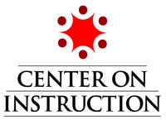
Adolescent Literacy Institute
New Orleans, LA
October 15-17, 2008

Focus Group Dialogue Guide

Focus Group Topic: _________________________

Below are a few questions to initiate conversation within your group. Feel free to answer all of these, only address the ones that interest you and your group members, or discuss other aspects of your topic all together.

- Why is this topic of high importance/interest to you?

- Who are some of the stakeholders involved in this area of adolescent literacy?

- What are some of the challenges associated with this topic?

- What are some of the causes or contributing factors of this topic (if it is an area that needs improvement)?

- What can be done by your RCC and/or in your state to improve this area of adolescent literacy? What are some resources/TA/support needed to accomplish these improvements?

