**LEARN WHAT WORKS Resources**



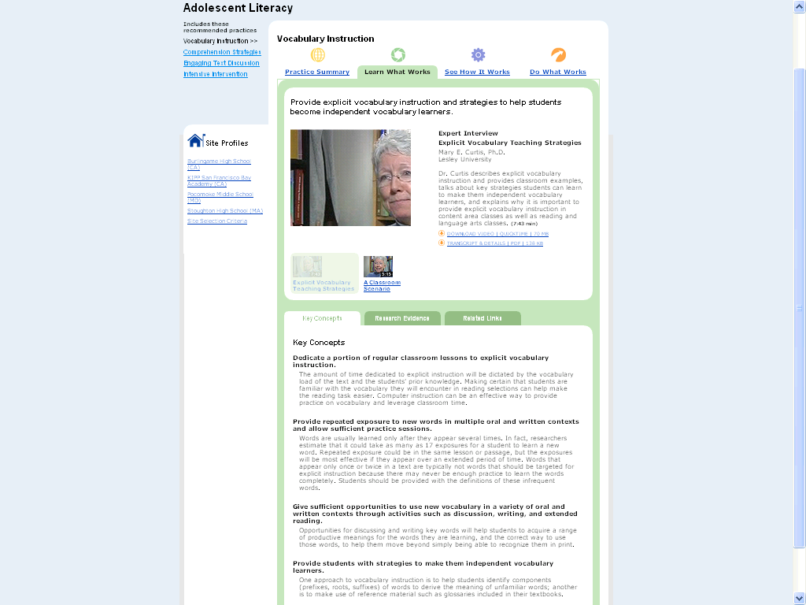

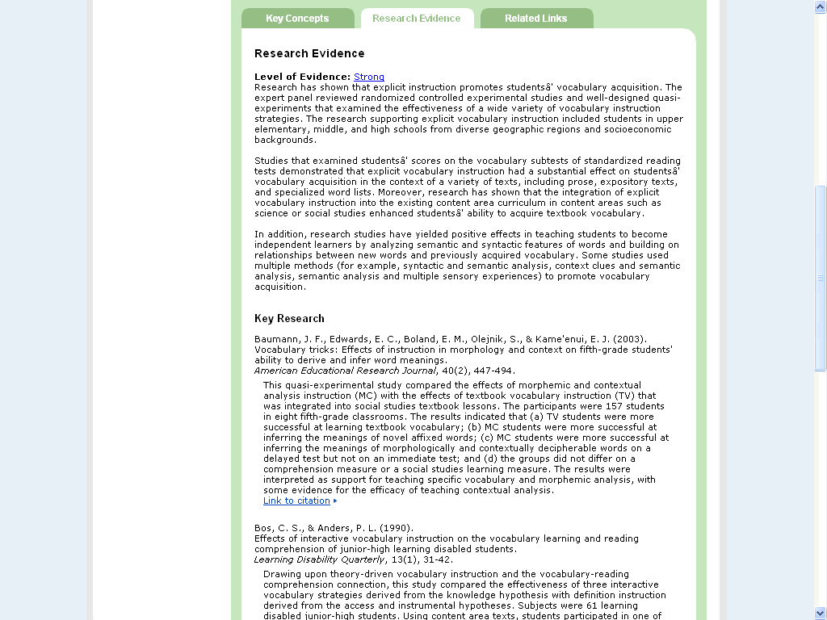

**SEE HOW IT WORKS Resources**



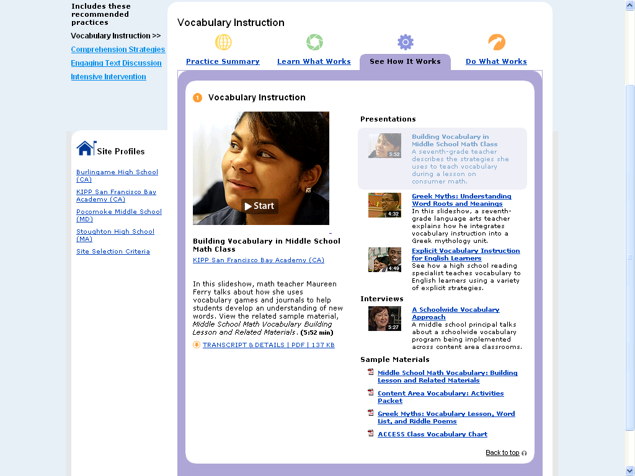

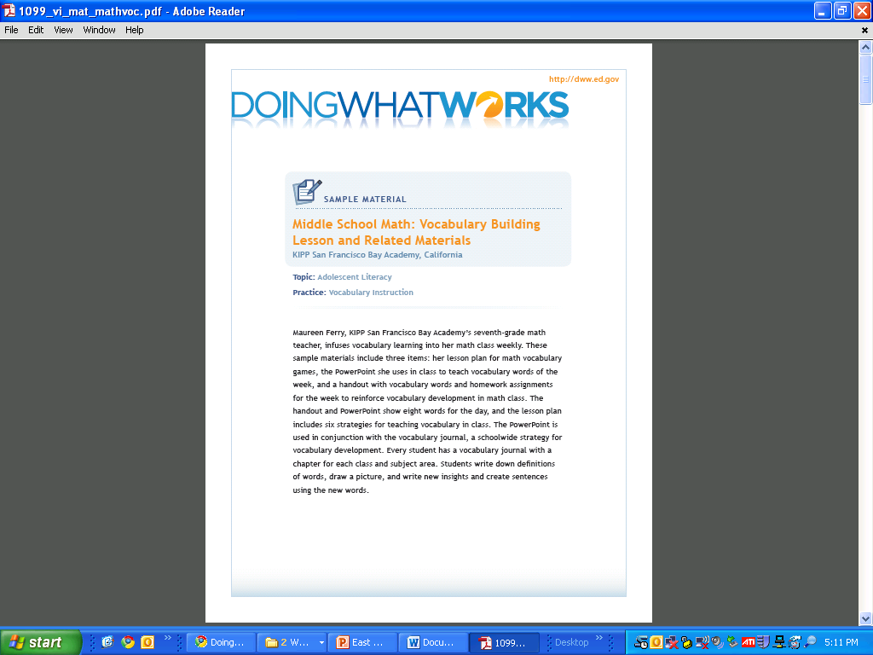

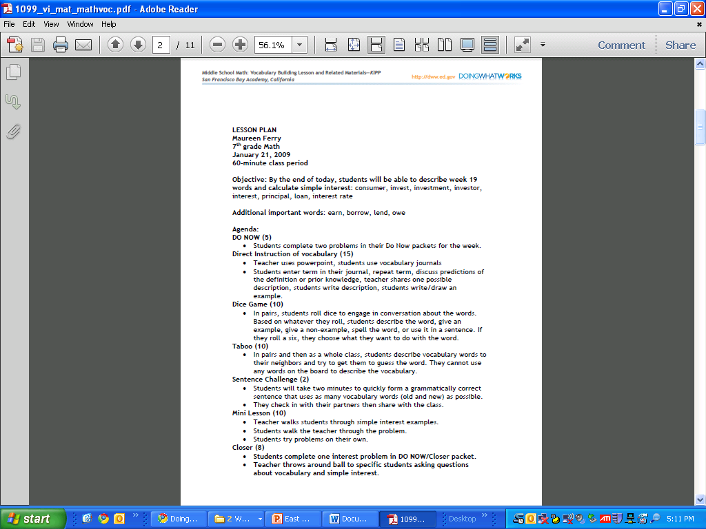

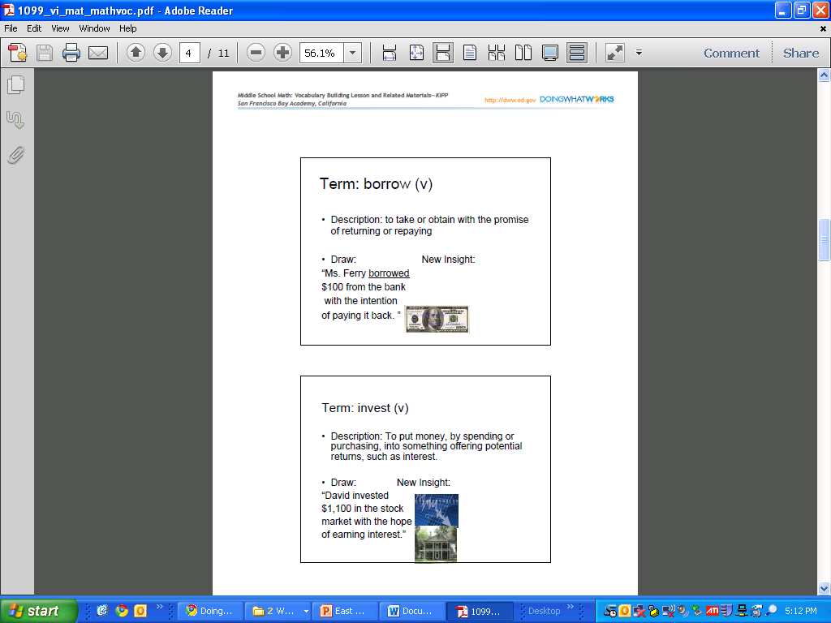

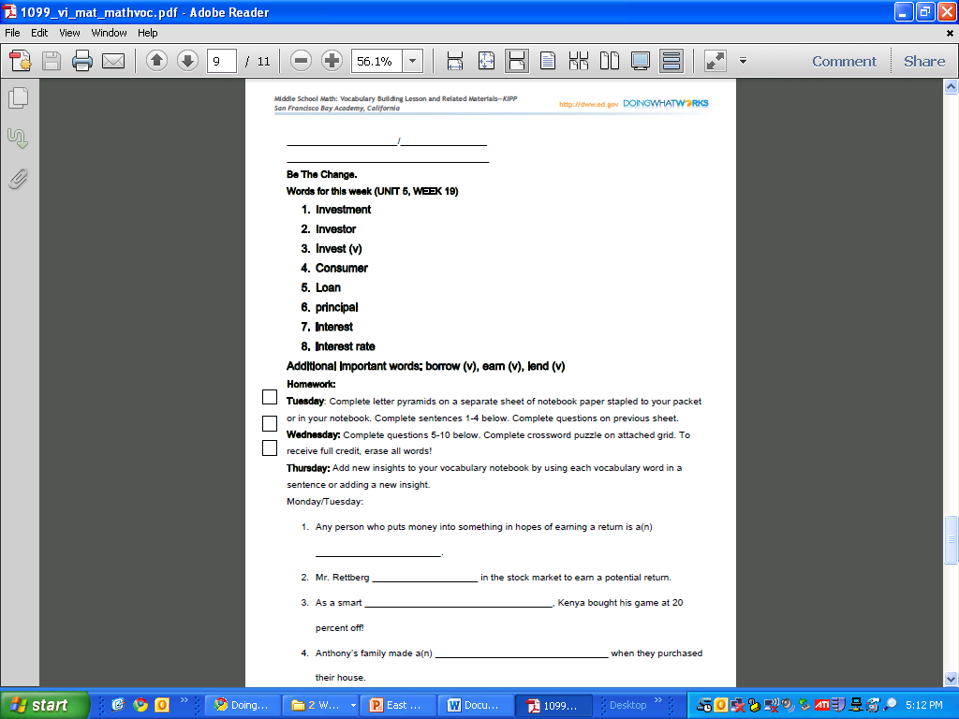

**DO WHAT WORKS Resources**



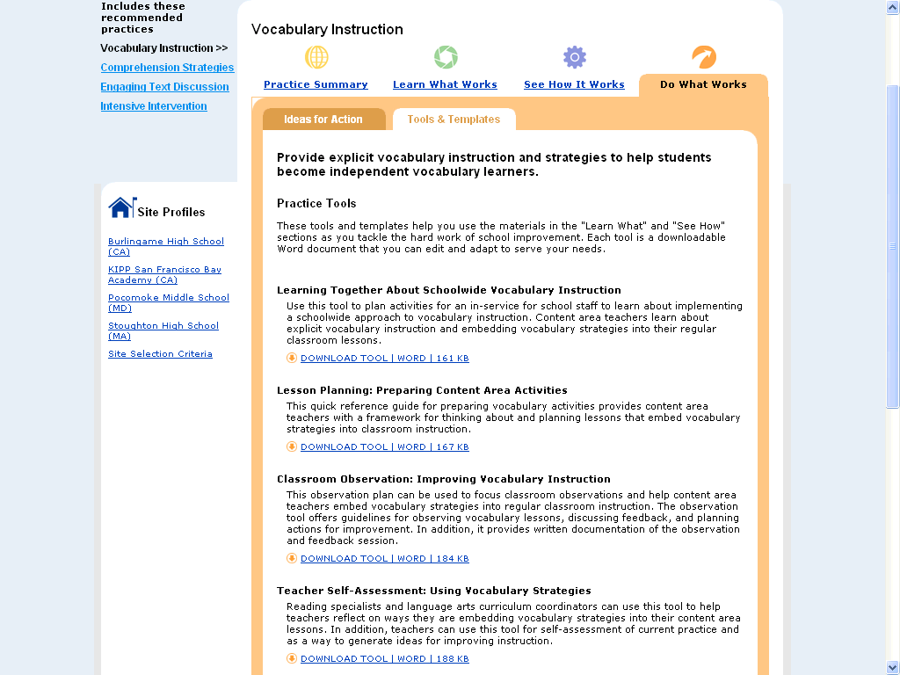

# Teacher Self-Assessment: Using Vocabulary Strategies

**Purpose** Reading specialists and language arts coordinators can use this tool to help teachers reflect on ways that they embed vocabulary instruction into content area lessons. In addition, teachers can conduct a self-assessment to think about current practices and generate ideas for incorporating vocabulary strategies into content lessons.

**Materials** *Content Area Vocabulary: Activities Packet*

*Middle School Math: Vocabulary Building Lesson and Related Materials*

**Media** *Explicit Vocabulary Teaching Strategies,* interview with Mary Beth Curtis, Harvard University (7:43)  
  
*Greek Myths: Understanding Word Roots and Meanings*, multimedia presentation with teacher from Pocomoke Middle School (4:32)  
  
*Building Vocabulary in Middle School Math Class*, multimedia presentation with teacher from KIPP San Francisco Bay Academy (5:52)

Topic Adolescent Literacy

Practice Vocabulary Instruction

## Teacher Self-Assessment: Using Vocabulary Strategies

Teacher reflects on a recently completed content lesson, notes level of satisfaction with vocabulary components and strategies, and suggests ideas for improvement.

| Embedded Vocabulary Instruction Components | Very satisfied | Somewhat satisfied | Not satisfied | Ideas for Improvement |
| --- | --- | --- | --- | --- |
| Planning lessons | | | | |
| 1. Includes vocabulary goals |  |  |  |  |
| 1. Embeds explicit vocabulary strategies in lesson |  |  |  |  |
| 1. Allots adequate time to teach vocabulary |  |  |  |  |
| Selecting words | | | | |
| 1. Identifies new words from text |  |  |  |  |
| 1. Includes relevant words from schoolwide list |  |  |  |  |
| **Using explicit strategies** | | | | |
| 1. Reviews words learned from previous lessons |  |  |  |  |
| 1. Introduces and provides clear explanation of new words |  |  |  |  |
| 1. Builds on students’ prior knowledge |  |  |  |  |
| 1. Provides repeated exposure to new words |  |  |  |  |
| 1. Uses multiple and varied contexts to teach vocabulary |  |  |  |  |
| Scaffolding Independent Strategies | | | | |
| 1. Helps students develop strategies for independent learning |  |  |  |  |
| 1. Models strategies for defining word meanings (e.g., context cues, word structure, and component analysis) |  |  |  |  |
| 1. Provides reference materials, such as computer software and textbook glossaries |  |  |  |  |
| Providing practice opportunities | | | | |
| 1. Provides in-class time and opportunities for independent practice of strategies |  |  |  |  |
| 1. Extends practice through follow up activities, such as computer-based experiences and homework assignments |  |  |  |  |
| Assessing learning | | | | |
| 1. Encourages multiple ways for students to show understanding |  |  |  |  |
| 1. Monitors student learning through frequent checks throughout lesson |  |  |  |  |
| 1. Conducts formal assessment to document student understanding |  |  |  |  |

